Easy-To-Read Survey for the new National Housing Strategy for People with Disabilities

March 2021

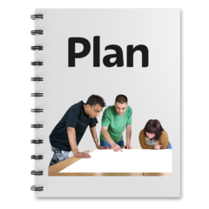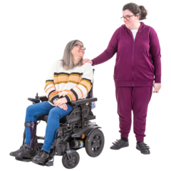 | The National Housing Strategy for People with a Disability (2011-2016 (extended to 2020)) will come to an end this year.  A new national strategy is now being made.  The strategy is about putting in place housing options and services to disabled people.  This would mean people would have more choice and support independent living.  Do you  - have a disability,  - care for a disabled person or  - work in supporting independent living for disabled persons?  If yes, have your say on the plan.

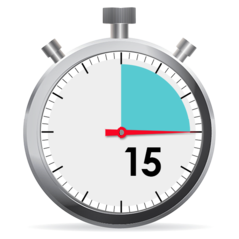 | We want to hear your views on the current strategy and what you would like to see included in the new national strategy.  In order to get involved today, fill out this 10-15 minute questionnaire.  The survey is anonymous and confidential.  There will be more consultation over Summer and Autumn.  Thank you for taking the time to let us know your views.

Question 1
Tell us who you are (Choose one answer by putting an X in the box below)
I am a disabled person
I am a family member
I am a carer
I am a member of the public

Question 2
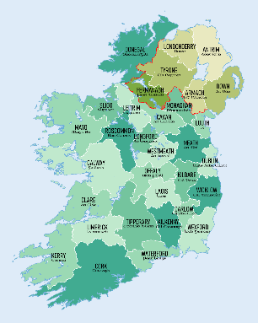 | What county in Ireland do you live in?  You can type your answer in the text box below

Question 3
What type of disability is most relevant to you? (Choose all that you know by placing an X below)
 | Physical disability
 | Intellectual disability
 | Mental Health
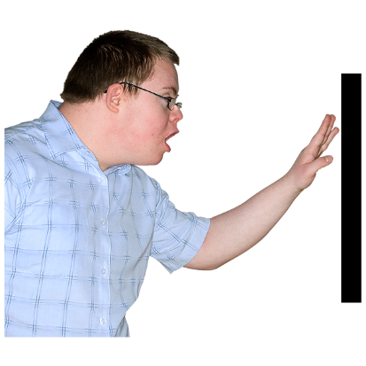 | Sensory disability
 | I would prefer not to say
 | This question does not apply to me

Question 4
What age are you? (Choose one answer by putting an X in the box below)
 | Under 18
 | 18-24
 | 25-34
 | 35-44
 | 45-54
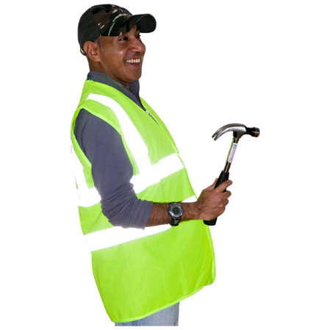 | 55-64
 | Older than 65

Question 5
Is there anything else you would like to say about yourself and your experience of housing?

Question 6
Before today, did you know anything about the National Housing Strategy for People with a Disability?
(Choose one answer by putting an X in the box below)
Yes
No

Question 7
Do you think access to housing has got better over the past few years?
(Choose one answer by putting an X in the box below)
 | I think it has stayed the same
 | It has got a lot better
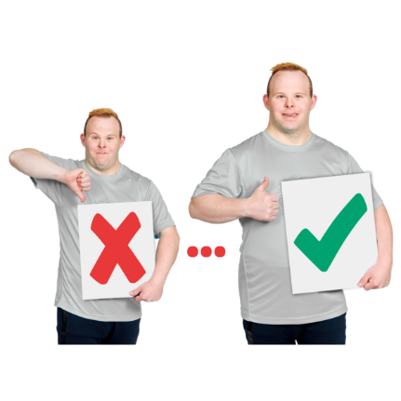 | It has improved a bit
 | I am not sure

Question 8
Which of these do you think are the most important issues for housing?
(Choose all that you know by placing an X below)
 | Support people to live independently
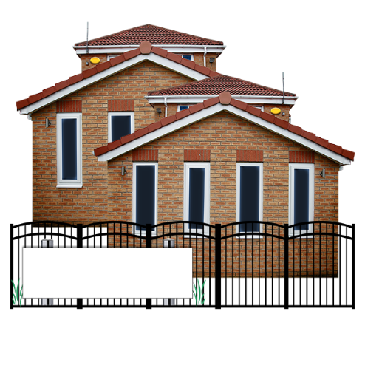 | Moving people out of institutions
 | Having equality in housing options for disabled people
 | Agencies working together so people can get housing and supports
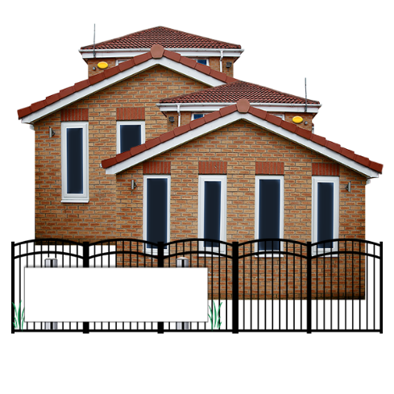 | Moving people out of mental health services
 | Providing housing advice and information in accessible documents
 | Having a collective approach to housing

Question 9
Do you know about what the housing strategy is supposed to do?
(Choose one answer by putting an X in the box below)
Yes
No
A little bit

Question 10
Each Local Authority has a plan for their area to help meet the needs of people with disabilities.

This plan is called a Local Strategic Plan.
Did you know about this plan?

(Choose one answer by putting an X in the box below)

Yes
No

Question 11
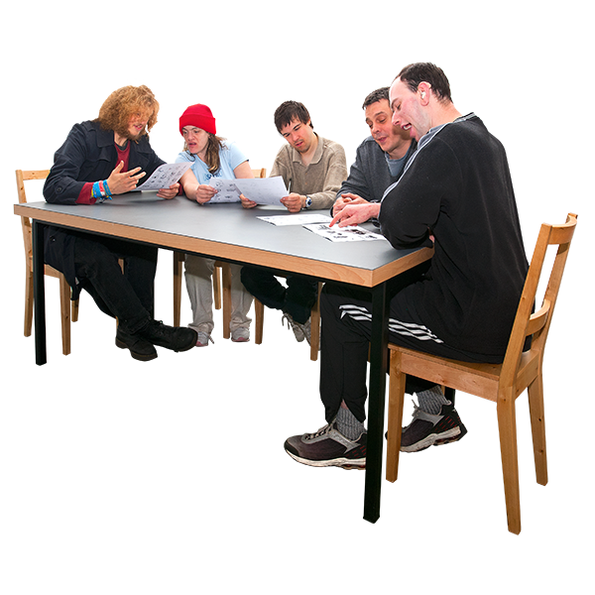 | Each local authority has a Housing and Disability Steering Group  This group helps to put in place the Local Strategic Plan in their area  Did you know about this group?  (Choose one answer by putting an X in the box below)
 | Yes
 | No

Question 12
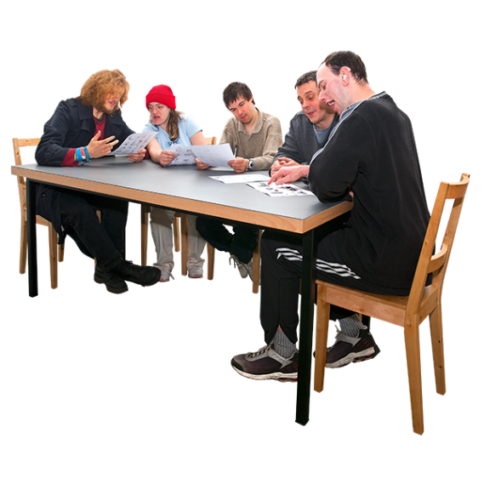 | Each Local Authority and the HSE can work together to support people with a disability to live independently or stay in their own home.  Did you know this?  (Choose one answer by putting an X in the box below)
 | Yes
 | No

Question 13
Do you know of any of the following housing options?
(Choose all that you know by placing an X below)
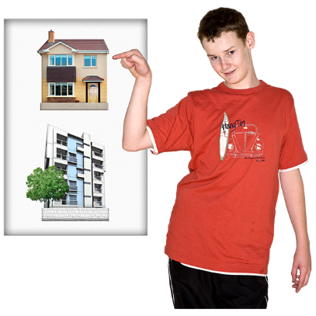 | Local Authority Housing or  Social Housing
 | Approved Housing Bodies or AHB’s
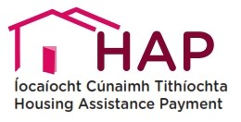 | Housing Assistance Payment or HAP
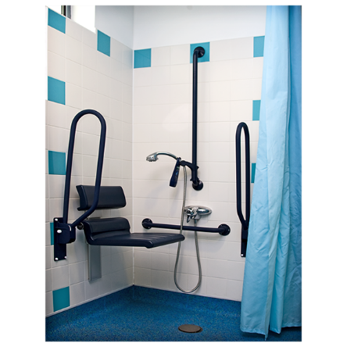 | Housing Adaptation Grants
 | None of these

Question 14
Do you think these housing options are well known by the public?

(Choose one answer by putting an X in the box below)
Yes
No

Question 15
In your opinion, how do you think getting access to these housing options can be improved?

You can type your answer in the text box below

Question 16
What do you think can be done to make it easier for people to have independent living?

You can type your answer in the text box below

Question 17
Organisations such as the HSE, Local Authorities and Service Providers must work together to support people to get housing
How do you think they can all work together in a better way?

You can type your answer in the text box below

Question 18
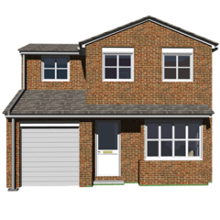 | What are the biggest challenges facing disabled people accessing housing?  You can type your answers in the text boxes below

Question 19
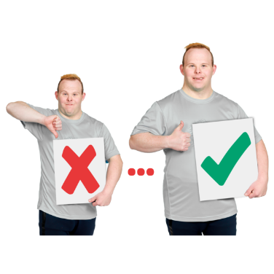 | The new strategy may continue some of the actions from the old strategy?  Which of these do you think should be continued or improved in the new strategy?  (Choose all that you know by placing an X below)
 | Housing & Disability Steering Group
 | Local Strategic Plans
 | Mental Health Tenancy Officers
 | Easy Read & Plain English Documents

Question 20
Are there any other actions you would like to see included?

You can type your answer in the text box below.

Question 21
What are the three main things you would like to see improved in the new housing strategy?

You can type your answers in the text boxes below

Question 22
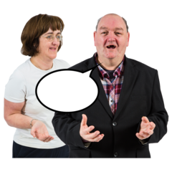 | Is there anything else you would like to say about the new strategy?  You can type your answer in the text boxes below

Thank you – What next?
Thank you for filling out this survey

You can email this back to us at disabilitystrategy@housingagency.ie

Or

Post to

Disability Strategy,
The Housing Agency,
53-54 Mount Street Upper,
Dublin,
D02 KT73

